UNC - Wilmington
Deliverable #1 - "Software Project Plan Document" Outline
Dillon Harless
Robbie Arnold
Alejandro Peña
Jamie Sparrow

Deliverable - “Software Requirements Analysis “
- Introduction
  - We plan to create online art gallery where people can view artwork and purchase pieces online. We plan to create the back end in MySql. Customers will create accounts, save shopping lists, and purchase items. We also plan to have an admin log-in page through which an approved website manager can edit content. The website will communicate with a database in order to satisfy most of the requirements.
    - Our team was contacted by a UNCW student who wanted this website created for his friend.
    - It will allow the client’s friend to reach more customers than his physical environment allows.
  - We have had multiple meetings with the client and gathered most of the requirements through elicitation.
- Requirements Specification/Scope
  - Create accounts, Hold records in accounts (names, addresses, emails)
  - User-Computer Interface Description – Input and Output Mockups
  - System Interfaces
  - Prioritization of Requirements
- Models
  - Use Case: 1 <Create Account>
    - Goal: <User accesses website, creates account, and views their account>
    - Primary Actor: <User>
    - Priority: <Highly critical>
    - Frequency: <Every time a new user wants to buy something>
    - <step #1> <User enters www.kyleowens.com, and the browser loads the page from the database.>
    - <step #2> <User clicks the button labeled “Create Account” and the website directs them to the corresponding page by loading it from the database.>
    - <step #3> <User enters data in the corresponding fields for Name, Address, etc., clicks the button labeled “Save” and the web page saves the data in the database.>
Scenario 1 – Valid Entries
- <step #4> <Website redirects user to their account page>
Scenario 2 – Invalid Entry(ies)
    - <step #4> <Website reloads the “Create Account Page” and displays a message concerning the invalid entry or entries.
    - <step #5> <User changes information and resubmits.>
    - ***Steps 4 and 5 are repeated as many times as is necessary***
    - <step #6> <Website redirects user to their account page>
  - Use Case: 2 <Login to Pre-existing Account>
    - Goal: <User accesses website, and logs in with account info>
    - Primary Actor: <User>
    - Priority: <Critical>
    - Frequency: <Every time a user wants to view products on the site with the option of saving a cart>
    - <step #1> <User enters www.kyleowens.com, and the browser loads the page from the database.>
    - <step #2> <User clicks the button labeled “Login” and the website directs them to the corresponding page by loading it from the database.>
    - <step #3> <User enters Username and Password in corresponding fields, and submits.>
    - <step #4> <Website checks with database to see if account exists and, if the account does exist , if the username and passwords match.
      - Scenario 1 – Account exists, Username and Passwords match
    - <step #5> <User is redirected back to the page they were on when they clicked “Login”>
      - Scenario 2 – Account exists, Username and Passwords do not match
    - <step #5> <Website reloads login page and displays a message informing the user that the password was incorrect>
    - <step #6> <User tries again.>
***Steps 5 and 6 are repeated as many times as is necessary***
    - <step #7> <User is redirected back to the page they were on when they clicked “Login”>
Scenario 3 – Account does not exist
    - <step #5> <User is redirected to the “Create Accounts” page. A message displayed says, “We do not have an account on record with for that username or email. Would you like to create an account?”>
  - Use Case: 3 <Add item to cart>
    - Goal: <User views product and adds it to their cart for purchasing later>
    - Primary Actor: <User>
    - Priority: <Critical>
    - Frequency: <Every time a user wishes to purchase something>
    - <step #1> <A user already on the website, logged in or not, clicks a purchasable product’s tab>
    - <step #2> <Website loads that product’s page>
    - <step #3> <User clicks “Add To Cart”>
    - <step #4> <Website adds the product to User’s cart without leaving the page, and the “Add To Cart” button changes to “Added” and is no longer clickable.>
  - Use Case: 4 <Checkout/Purchase>
    - Goal: <User purchases all items in their cart after any edits are made>
    - Primary Actor: <User>
    - Priority: <Critical>
    - Frequency: <Every time a user wishes to checkout>
    - <step #1> <User clicks “Checkout”, after adding item(s) to their cart.>
    - <step #2> <Website redirects User to the Checkout page.>
    - <step #3> <User removes anything they do not wish to purchase from their cart. The web page displays the total amount due>
Scenario 1 – User is logged into an account
    - <step #4> <User clicks “Proceed to Checkout” and is redirected to a page displaying their address and other information>
    - <step #5> <User clicks the PayPal button and logs into PayPal>
    - <step #6> <Website loads a page that thanks User for their purchase>
Scenario 2 – User is not logged into an account
    - <step #4> <User clicks “Proceed to Checkout” and is redirected to a page with empty fields corresponding to required data such as address and phone number.>
    - <step #5> <User clicks the PayPal button and logs into PayPal.>
    - <step #6> <Website loads a page that thanks User for their purchase.
  - Class Diagrams
  - Activity Diagrams/Data Flow Diagrams
  - Entity Relationship Diagram
  - Use case diagrams (At least 3 actors)
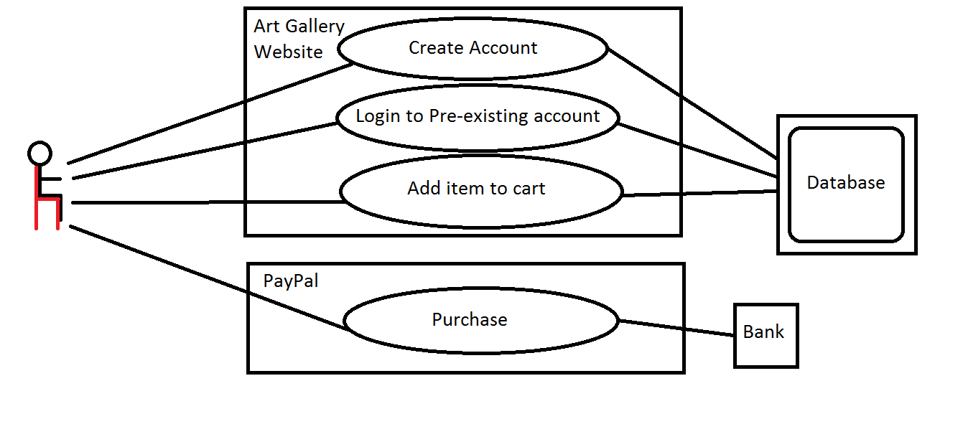
- Plan
  - Project estimate
  - Risk Management Plan
    - ***Completed in a separate document***
  - Project Plan in Microsoft Project (Work Breakdown Structure)
    - GANTT chart ***Tasks over time***
    - PERT/CPM chart ***Critical path chart***
- Meeting notes
  - Frequent and productive meetings.
  - Continued updates from, and meetings with, client.
  - Clear responsibilities set in place. Any questions were answered by other members.
  - Solid flow of discussion by all members, especially when creating the CRC Cards, which was one of the most challenging parts of our project so far.

